Hello, Team!

I’m excited to share a new Excel application I developed called TOAST!



TOAST is an acronym for “Trained and Onsite Associate Synchronization Tool”. TOAST was designed to find Associates that are trained in a process, who are also onsite (just as the name suggests).

The dates and times will update automatically to the current day, and the time will update automatically to the previous hour.

Just select the desired shift:

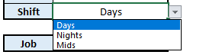

Select the desired job:  
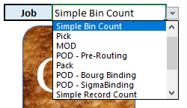

And click “GO!”



A message will pop up confirming successful results, click “OK”:  
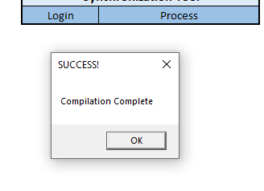

A list of all the associate’s logins that are on the shift and trained in that path will populate:  
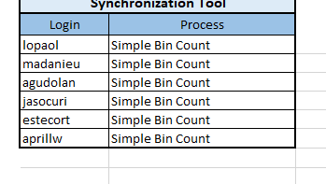

If you have any additional questions or feedback regarding this tool, feel free to reply to this email.